**Beach Party**

**Saturday August 4th**

Food 6-8pm

**Hog Roast Dinner $10**

Baked Potato

Cole Slaw

Corn on the cob

Watermelon

Root Beer Floats

Ted’s Famous Rum Punch

Music 7-11pm__________________Local Craft Beers___

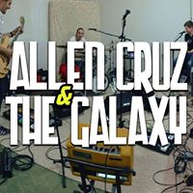 

Beach Games: Corn Hole & Giant Jenga

Bon Fire after Sunset