[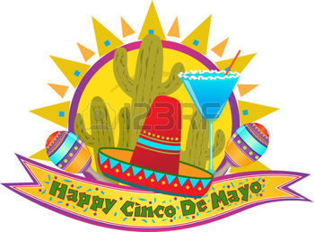](http://www.123rf.com/photo_27004178_cinco-de-mayo-banner--happy-cinco-de-mayo-banner-with-sombrero-maracas-and-margarita-eps10.html)

***HOLD ON TO YOUR SOMBREROS! WE ARE THROWING A***

***F I E S T A***

***DATE: FRIDAY MAY 4, 2018***

***TIME: 6PM***

***PLACE: PORT CLINTON YACHT CLUB***

***FOOD: $7.00***

***MARGARITAS: $3.00***

[](http://www.123rf.com/photo_26468706_a-happy-cartoon-sombrero-jumping-and-smiling.html?term=cinco%2Bde%2Bmayo&vti=ode77vfshqzdsq84rz)