

**Derby Day Bar Party**

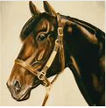

Try picking a winning horse

**Saturday May 5th 2018**

Board for Horses will be available through the day

Race starts round 6:30 PM

**Pull Pork sandwiches, slaw, Derby desert**

**From 5 – 7 pm**

**$6.00 per person**