**July 13th Friday Night Snacks**

**National Beanie-Weenie Day!!**

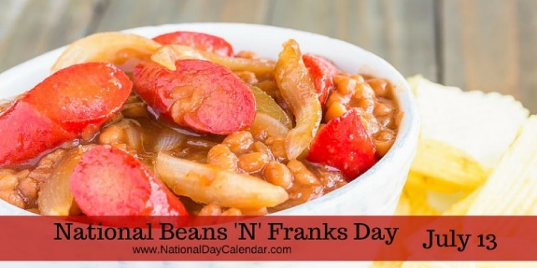

**Featuring:**

[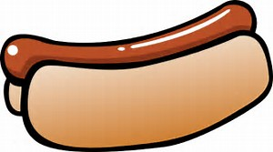](https://www.bing.com/images/search?view=detailV2&ccid=Rp6oHecj&id=DB7541E2E548BE84E97F24152805B697B1D3B662&thid=OIP.Rp6oHecjBTLDsy6UTy3r2gEsCn&q=hot+dog+pictures+clip+art&simid=608054047976459189&selectedIndex=0)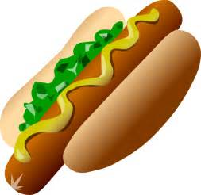

**Hot Dogs and Brats**

**Baked Beans**[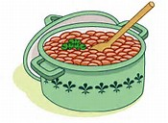](https://www.bing.com/images/search?view=detailV2&ccid=/WSR%2bwov&id=C7CC4E55174D3FC29F5D52A5877BE00C66B1E8B5&thid=OIP._WSR-wovyYG2thNxqqmKagDiCl&q=Bowl+of+Beans+Clip+Art&simid=607989730822128865&selectedIndex=23)

**Assorted Veggies & Chips**

**Dessert**

**$6 @ 6PM**